Meeting Minutes
February 25, 2021
- Check-In and Announcements
  - Janice Schutz (WSCC) – Many events recently, system navigation workshops
  - Jill McCormick (PAVE) – F2F Newsletter, COVID and emergency prep resources
  - Nikki Dyer (DoH) – New strategic plan for CYSHCN in the works
  - Louis Mendoza (Kindering/Father’s Network) – Fatherhood Summit “Parenting in Difficult Times” March 16th-18th
  - Tracy Hoppis (WA P2P) – Parent who took Louis’ “Telling Your Story” spoke at Advocacy Day; upcoming Coordinated training; supportive decision-making training had 50 people
  - Kari Cunningham-Rosvik (WSU doctoral student) Studying on
  - Vanessa Allen (ESIT) – newsletter now out, e-mail her if you have anything to add to it: vanessa.allen@dcyf.wa.gov
- Prioritization for 2021
  - Why does WSLI not have the desired outreach?
    - No extra time for organizational members
    - Need to inform others on how it is a forum for information on other organizations, their events and resources
  - Program directors and executives need space to discuss administrative matters with their peers – “roundtable chat”
  - For each meeting – ensure agenda with time for origination information exchange
  - Website needs to reflect that WSLI is a coalition of organizations
  - Keep to the WSLI core activities: Share trainings, resources, funding sources, and technical assistance; Provide leadership opportunities to families; Advocate for increased access to services; Simplify connections with state agencies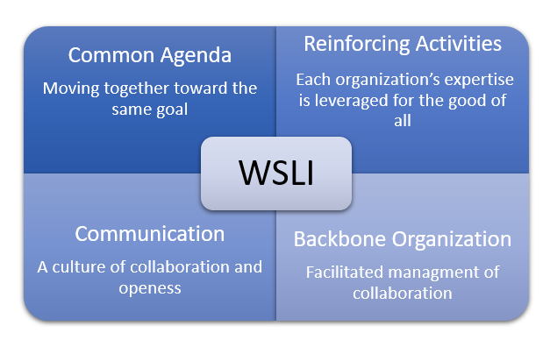
  - Bring in specifically targeted group to present (i.e. Open Doors)
  - Create repository for advisory and other groups needing family leaders

