Location: https://us02web.zoom.us/j/83326023882
Date: February 15th 2023, 9-10 am
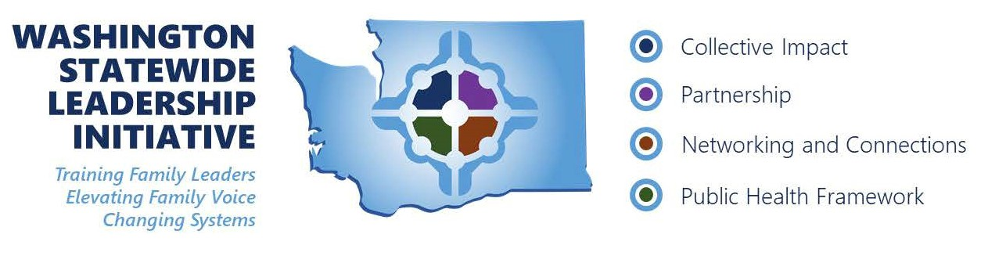
- Check In
  - Are there any upcoming events put on by your organization that you would like us to spread the word on?
- Get to know our organizations aka “speed dating”
  - Decide on date and time of event
    - Response to which days in April would work best:
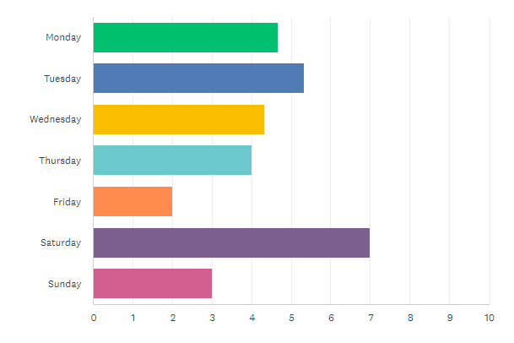
  - Organizations Presenting (4-5 total)
    - Statewide P2P – Tracie Hoppis
    - Washington State Hands & Voices – Christine Griffin
    - Guided Pathways – Pattie Marshall
  - Who will host?
  - How to promote
  - Other considerations
    - ASL and Spanish?
- Next Steps

